import java.util.Scanner;
import java.util.InputMismatchException;
class Calculator
{

public void add(float a,float b, float c)
{
System.out.println(a+"+"+b+"+"+c+"="+(a+b+c));
}
public void add(float a,float b)
{
System.out.println(a+"+"+b+"="+(a+b));
}

public void subtract(float a,float b, float c)
{
System.out.println(a+"-"+b+"-"+c+"="+(a-b-c));
}
public void subtract(float a,float b)
{
System.out.println(a+"-"+b+"="+(a-b));
}

public void product(float a,float b)
{
System.out.println(a+"*"+b+"="+(a*b));
}

public void division(float a,float b)
{
System.out.println(a+"/"+b+"="+(a/b));
}
}
public class Main
{
public static void main (String[] args) {
Calculator cal=new Calculator();
Scanner sc=new Scanner(System.in);
System.out.println("Author: y.sushmitha \nSAP ID:51834576");
try
{
System.out.println("1. ADD\n2. SUBTRACT\n3. MULTIPLICATION\n4. DIVISION\n5. EXIT\nEnter your choice: ");
int op=sc.nextInt();
switch(op)
{
case 0:
System.out.println("Exit...");
System.exit(0);
break;
case 1:
System.out.print("Enter operand 1: ");
float add1=sc.nextFloat();
System.out.print("Enter operand 2: ");
float add2=sc.nextFloat();
System.out.print("Enter operand 3(if you want. else enter 0): ");
float add3=sc.nextFloat();
if(add3==0)
{
cal.add(add1, add2);
}
else
{
cal.add(add1, add2, add3);
}
break;
case 2:
System.out.print("Enter operand 1: ");
float sub1=sc.nextFloat();
System.out.print("Enter operand 2: ");
float sub2=sc.nextFloat();
System.out.print("Enter operand 3(if you want. else enter 0): ");
float sub3=sc.nextFloat();
if(sub3==0)
{
cal.subtract(sub1, sub2);
}
else
{
cal.subtract(sub1, sub2, sub3);
}
break;
case 3:
System.out.print("Enter operand 1: ");
float mul1=sc.nextFloat();
System.out.print("Enter operand 2: ");
float mul2=sc.nextFloat();
cal.product(mul1,mul2);
break;
case 4:
System.out.print("Enter operand 1: ");
float div1=sc.nextFloat();
System.out.print("Enter operand 2: ");
float div2=sc.nextFloat();
if(div2==0)
{
throw new ArithmeticException("Number cannot be divided by zero!!");
}
cal.division(div1,div2);
break;
default:
System.out.println("Invalid choice: ");
}
}
catch(InputMismatchException ime)
{
System.out.println("You have entered input of wrong datatype!!");
}
catch(ArithmeticException ae)
{
System.out.println(ae.getMessage());
}
}
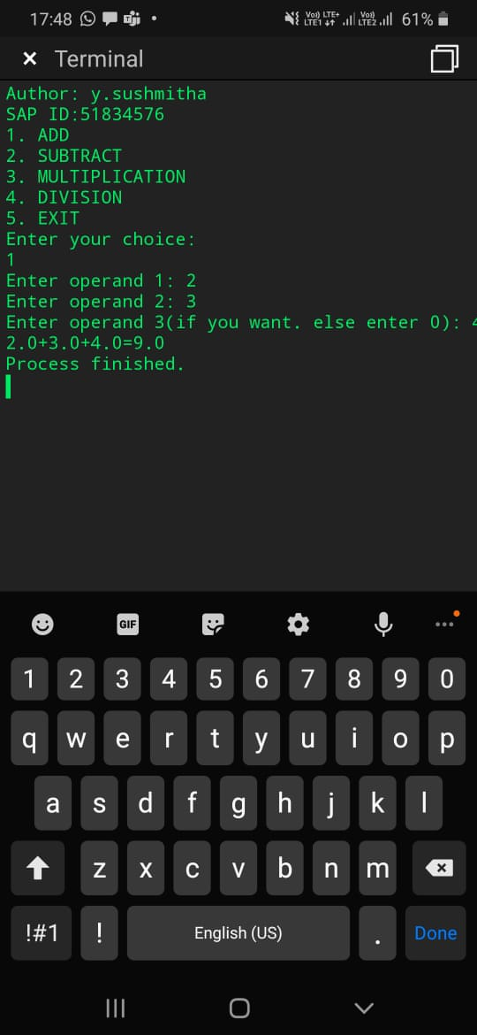}
2 )public class Main
{
public static boolean isPalindrome(String string, int low, int high)
{
if (low >= high) {
return true;
}

if (string.charAt(low) != string.charAt(high)) {
return false;
}

return isPalindrome(string, low + 1, high - 1);
}

public static void main(String[] args)
{
String string = "12321";

if (isPalindrome(string, 0, string.length() - 1)) {
System.out.println("Author:y.sushmitha \nSAP ID:51834576");
System.out.print("given String is Palindrome");
} else {
System.out.print("given String is Not Palindrome");
}
}
}

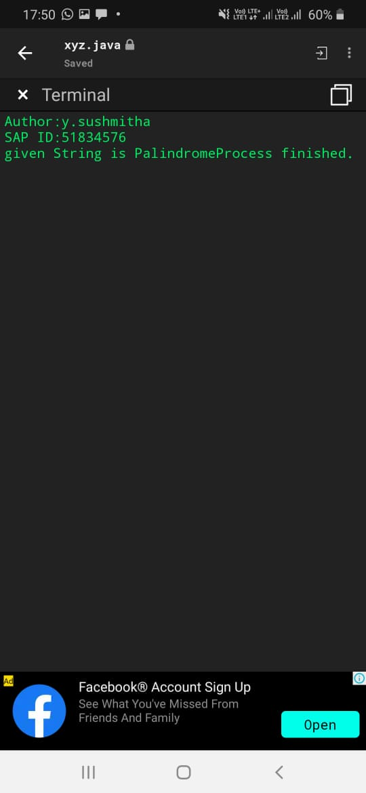
import java.util.*;
public class Main
{
public static void main (String[] args)
{
System.out.println("Author:y.sushmitha \n SAP ID:51834576");
int count=0;
int rem=0 ;
Scanner sc=new Scanner(System.in);
System.out.println("enter a number :");
int n= sc.nextInt();
while(n>0)
{
rem=n%10;
if(rem%2!=0)
{
count++;
}
n=n/10;

}
System.out.println("no of odd digits in number are ; "+count);

}

}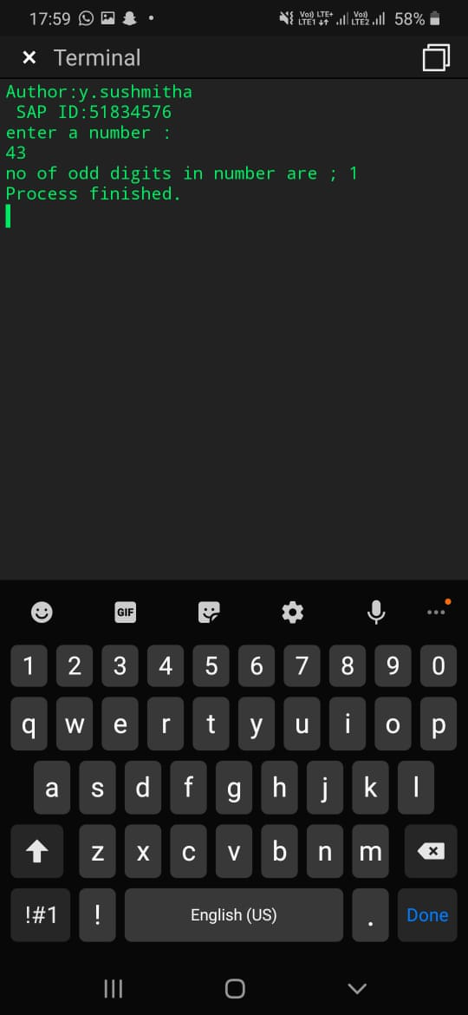
import java.util.Arrays;

class Main
{
public static void swap(int[] arr, int a, int b)
{
int temp = arr[a];
arr[a] = arr[b];
arr[b] = temp;
}

public static void bubbleSort(int[] arr, int m)
{
for (int a = 0; a < m - 1; a++) {
if (arr[a] > arr[a + 1]) {
swap(arr, a, a + 1);
}
}
if (m - 1 > 1) {
bubbleSort(arr, m - 1);
}
}

public static void main(String[] args)
{
int[] arr = { 5, 1, 7, 9, 8, 0, 2 };

bubbleSort(arr, arr.length);

System.out.println("Author:y.sushmitha \n SAP ID:51834576");
System.out.println(Arrays.toString(arr));
}
}
